Project Design Phase-I Solution Architecture

Date

Team ID

22 OCTOBER 2022

PNT2022TMID45717

Project Name

SmartFarmer – IoT Enabled Smart Farming Application

Maximum Marks

4 Marks

**Solution Architecture:**

* The different soil parameters (temperature, humidity, Soil Moisture) are sensed using different sensors, and the obtained value is stored in the IBM cloud.
* Arduino UNO is a microcontroller which used to processes the data obtained from sensors and weather data from weather API.
* Node-red is used as a programming tool to wire the hardware, software, and APIs. The MQTT protocol is followed for communication.
* All the collected data are provided to the user through a mobile application that was developed using the MIT app inventor. The user could make a decision through an app, whether to water the crop or not depending upon the sensor values. By using the app they can remotely operate the motor switch.

**Solution Architecture Diagram:**

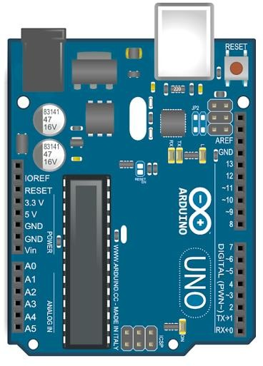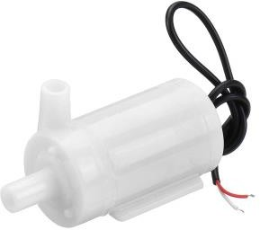



Cloud

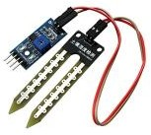

Soil Moisture Sensor

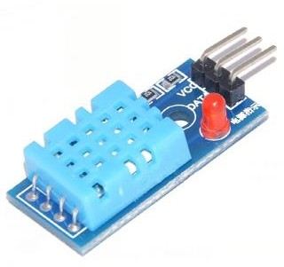

DHT11 Sensor



User



Motor

Open

Weather Api

Node Red

Application